Çatalhöyük – A Neolithic Village

Çatalhöyük is a neolithic village site found in Turkey. You will study maps, read a short article, and then analyze artifacts from Çatalhöyük. As you study Çatalhöyük, focus on this question:
How was life different for people living in agricultural villages compared to life in foraging communities?

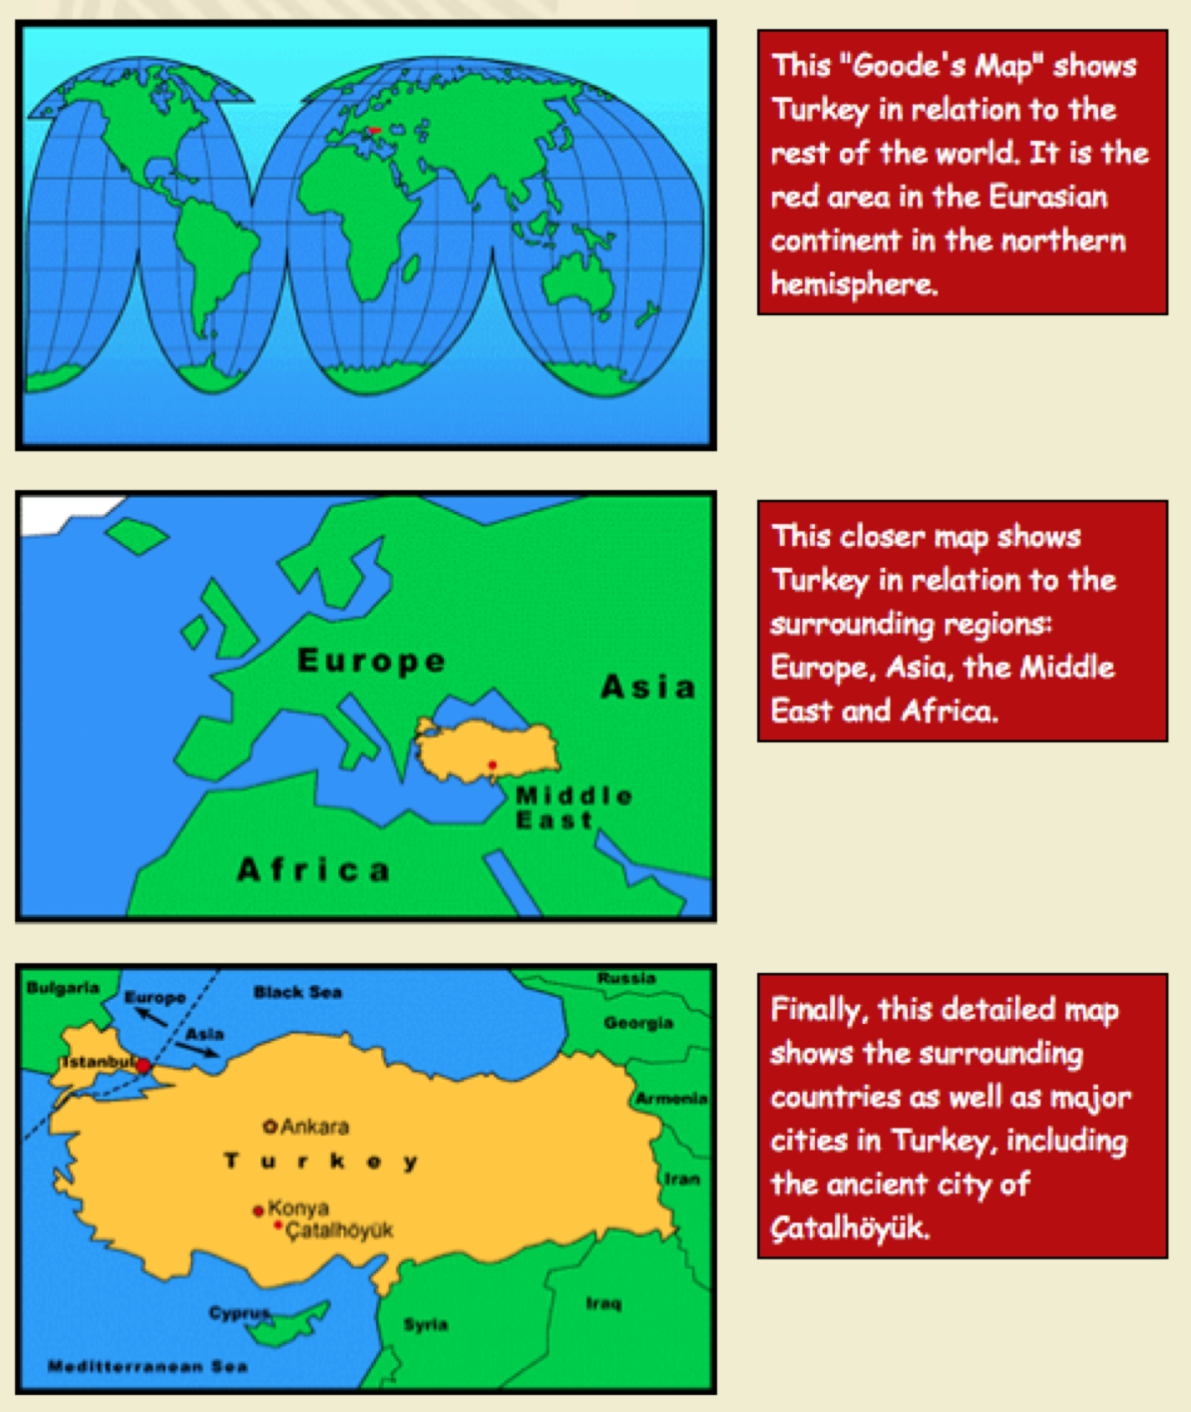

About Life and Work at Çatalhöyük 9,000 Years Ago

Read the two paragraphs below and Stop and Jot in response to the questions.

In Turkish, the word Çatalhöyük (say “cha-tal-HU-yuk”) means “forked mound,” referring to a footpath that once split between the east and west mounds that make up the 70-foot-high remains of the settlement today. In Neolithic times, the two mounds straddled a river, long gone today, which could provide fresh water and food for the village, including fish and the eggs of water fowl. At the time, the environment was a semiarid plain, dominated by low-growing grasses, sedges, and small bushes. In the spring, the area would have been surrounded by wetlands, offering mud and reeds as building materials.

The Neolithic was a time when people were beginning to settle down, living in collected family groups and staying in one location throughout the year, rather than travelling from place to place depending upon the season. This new way of life—sometimes called the “Neolithic revolution”—drew on the most sophisticated skills and abilities of the people of the time. People began to find new uses for all of the materials their environment had to offer. Perhaps most important, they began to work together, forging long-term relationships that intensified as each generation added to the skills, knowledge, and abilities of the group. In the environment of a settled village, these increasingly complex interactions began to require new types of organization and structure, ultimately laying the foundation for our modern way of life.

Stop and Jot:

- Why do you think people developed a village in this particular site?

- How was life different for people living in agricultural villages compared to life in foraging communities?

Agricultural Villages | Foraging Communities

Çatalhöyük – Thinking about How We Learn about the Distant Past

Working with your partner, read the article below. There are questions embedded in the article. Stop reading and discuss the questions with your partner, agree on an answer, and each write it down. If you have different ideas, you can each include your own ideas as well.

The New York Times; September 7, 2011
Into the Stone Age With a Scalpel: A Dig With Clues on Early Urban Life
By SUSANNE FOWLER

CATALHOYUK, TURKEY — A pair of space-age shelters rising from the beet and barley fields of the flat Konya Plain are the first clue to the Catalhoyuk Research Project, where archaeologists are excavating a 9,000-year-old Neolithic village. Catalhoyuk — where people occupied mud-brick houses from about 7400 B.C. to about 6000 B.C. — is 60 kilometers, or 37 miles, southeast of Konya in central Turkey. The area is dotted with gently rising mounds that obscure the ancient roots of urbanization and draw archaeologists from around the world.

The area was first excavated in the 1960s by another Briton, James Mellaart, now 85, who established that it had been home to an advanced culture of people transitioning from a nomadic hunter-gatherer lifestyle to a more settled farming life. Their houses were uniformly rectangular, and entered by holes in the roof rather than front doors. Each had a hearth and an oven, plus platforms that seemed to have been used for sleeping. When a new house was needed, it was built atop the old one. The houses also served as cemeteries: The dead were buried beneath the floor.

Another find this summer was a row of 11 handprints inside a house and above a burial platform. Still another was the discovery of a young calf’s head that had been painted red and installed in a house, above a platform that covered nine burials.

- What sort of materials would have been needed to build Çatalhöyük?

- What types of jobs would people have to do to build the housing?

“One sort of pattern that we noticed is that the paintings seem to be concentrated around burial platforms,” Dr. Hodder said. “We don’t really understand what that relationship is. Is it a way to communicate with the dead? Another idea would be that the paintings are there to protect people from the dead, or to protect the dead from people.”

Over more than 1,400 years, as many as 16 layers of housing were formed, each serving as many as 8,000 people. Dr. Hodder’s team has dug through all 16 layers to reach a lake bed from the Pleistocene era. “From the excavations to date,” said Shahina Farid, the project’s field director from University College London, “we find that all of the houses are built up against each other. There are no streets or alleys. It was a very dense population. But a lot of activity would have taken place at the roof level. And the traversing would have been at the roof level as well. And in between groups of houses were these open areas where they chucked out their rubbish. It’s those areas that are the richest for us because they actually kept their houses very clean.”

- How would life be different in a village with thousands of people than with a group of 50? Include potential problems that might have developed with the larger numbers.

Thousands of People | Group of 50

- What types of solutions did people probably develop in response to these problems?

- What new social institutions, rules, or customs might have been needed to address these problems?

- What social institutions and rules would they have needed to deal with food distribution?

- How do they think they dealt with problems like crime and violence?

For Ms. Farid, deciphering the inscrutable is part of the appeal. “Archaeology will always engage people because it’s putting a puzzle together,” she said during an interview at the site. “And it’s a puzzle we will never, ever complete. There are always going to be missing pieces and it’s that sense of awe — that there are things we do today that people were doing 9,000 years ago. You can’t help but be awed by that.”

“We are trying to understand why they chose this spot to live. We look at what we call their art. Why were they so interested in bulls? Why were they using certain geometric designs? What were daily activities and what were ritual activities? We try to define this,” she said. “Are we looking at the beginnings of religion? And what is all this symbolism telling us about the beginnings of civilization?”
If it sounds a bit like detective work, it is. The team even has a fire forensics expert working with the site.

“Archaeology is a bit like C.S.I.,” Ms. Farid said, referring to the Crime Scene Investigation television series. “There are certain things we know happened. A wall is a wall is a wall. But someone else might turn up and say why do you think that’s a wall? And you look at them and you think, well, it’s mud-brick and it’s a wall. Sometime in the future someone will start questioning why we interpreted something as a wall. But for now, we can only interpret based on the data that we have at hand.”

- How do we learn about people living during this time of history and what limits our ability to know more?

- What kind of educated guesses do archaeologists have to make, and why do they have to guess in the first place?

Çatalhöyük Artifacts – Thinking about Skills and Resources Needed

With your turn and talk partner, study the pictures below and read the paragraphs on the next page. The drawing of the village is an artist’s visualization of what it would have looked like. The statue and the knife are artifacts found at the village site.

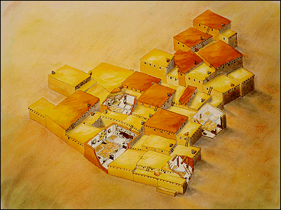

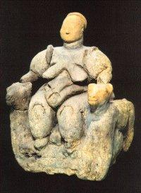

Stone Figurine (statue) Flint Dagger

Excerpts from “REMIXING ÇATALHÖYÜK”

Read the following paragraphs about ÇATALHÖYÜK. On the next page (table), brainstorm a list of some of the skills and natural resources people would have needed to build the village and create the objects and artifacts found on the site. Answer the questions in each row.

During the Neolithic, people learned to weave baskets from plant materials, and to make cloth from a variety of sources, including plant fibers and animal hair. They used animal furs and hides, as well as vegetable fibers such as flax, for clothing and bedding. They used wood, stone, shell, bone, and animal horn to make tools, weapons, and household implements. At Çatalhöyük, the local clays were used to make building bricks and plaster for construction, to create decorative items (such as the tiny beads found in an infant’s grave at Building 3), and to make sculptures. In fact, though we can only speculate about spiritual belief during the Neolithic, clay sculptures of corpulent female nudes found throughout the settlement have been the source of some people’s beliefs that an “earth mother” cult once thrived there.
At Çatalhöyük, people had begun to experiment with making pottery by firing objects such as figurines, clay balls, and even containers; and while they were still relying on many wild food sources, they were beginning to domesticate both plants and animals. In Building 3, the remains of boars (wild pigs) and aurochs (wild cattle, now extinct) have been found alongside the remains of domesticated sheep and goats. Cultivated foods such as wheat, barley, peas, and lentils have also been found inside the houses, but these were not grown in the marshy areas around the houses. Çatalhöyük was a farming settlement, but evidence has shown that some of the crops they tended were located well away from their homes.
The buildings at Çatalhöyük were built side by side and one on top of another for more than a thousand years, starting around 9,000 years ago. Houses were built right up against each other, interlocking like the cells of a honeycomb, with few spaces in between for pathways or roads. In fact, there were few exterior door openings in the maze of buildings at Çatalhöyük. Instead, most houses were entered through openings in the roof. Archaeologists have found evidence that people climbed up and down steep stairs or ladders to enter and exit most buildings. As a result, the roofs of the houses served as the “streets” of the village, offering additional work and living space. In some places, piles of refuse and rotting organic material filled the spaces between the buildings—conditions that may have contributed to the rooftop habits of the inhabitants.
Inside each mud-brick house were one, two, or three multi-purpose rooms that would have been shared by a family of five to ten people. Some parts of the house were used for storage and workspaces; other areas were used for food preparation, sitting, sleeping, and perhaps telling stories. Clay ovens provided warmth, light, and fires for cooking, but there is evidence of open hearths in other areas of the houses as well. Floors and walls were plastered with layers of thick white lime mud, and then regularly re-plastered to protect the structure beneath.

Thinking about Skills and Resources Needed Chart

 | Skills needed | Resources needed | Questions
12. Housing |  |  | Why do you think there were no doors to the outside in these homes?
13. Art and cultural objects |  |  | What types of objects were found?
14. Tools |  |  | What types of tools do you think people there would have needed?
15. Other objects mentioned in article (pottery, ladders, etc.) |  |  | What other objects do you think people needed?

