Choosing A Location
Directions: You are an elder of a tribe that has 100 people. An unfriendly group is forcing you off of your land and your group has decided to relocate to a new homeland. You sent out scouts to search for a new homeland. Three full moons pass and finally the scouts have returned! The scouts sit down with you to describe of the possible locations for resettling. They propose five possible sites.

Analyze the map with your Council of Elders and discuss the pros and cons of each site.
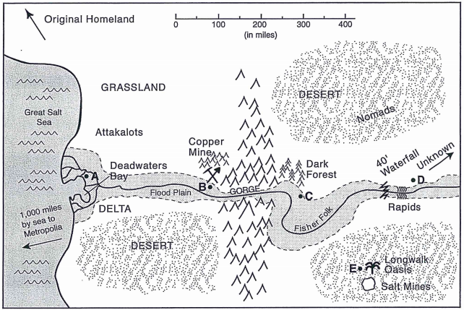

A | Pros:  Cons: | B | Pros:  Cons:
C | Pros:  Cons: | D | Pros:  Cons:
E | Pros:  Cons:
Which site will you recommend to the council? Why?

________________________________________________________________________________________________________________________________________________________________________________________________________________________________________________________________________________________________________________________________________________________________________________________________________________________________________________________________________________________________________________________________________________
________________________________________________________________________________________________________________________________________________________________________________________________________________________________________________________________________
________________________________________________________________________________________________________________________________________________________________________________________________________________________________________________________________________
________________________________________________________________________________________________________________________________________________________________________________________________________________________________________________________________________

